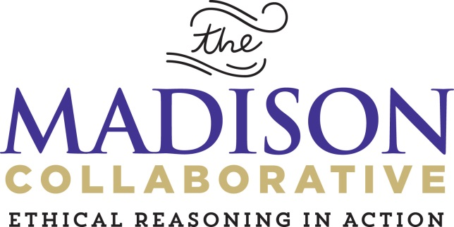

MADISON COLLABORATIVE 2016-2017 ANNUAL ASSESSMENT REPORT

Madison Holzman, M.Ed.
Allison Ames, Ph.D.
Liz Pyburn, M.A.

Center for Assessment and Research Studies

James Madison University

The 2016 – 2017 school year marked four years of Madison Collaborative: Ethical Reasoning in Action interventions. Similar to previous years, all first-year students experienced It’s Complicated during 1787 Orientation, prior to taking the Madison Collaborative assessments. There were no other required interventions for students, though students may have experienced ethical reasoning training in coursework and/or co-curricular experiences. In this report, the majority of comparisons are longitudinal. That is, results provide insight into how the same students performed on the assessments as first-year students and as second-year students. Longitudinal comparisons allow Madison Collaborative stakeholders to identify how students’ ethical reasoning skills and attitudes changed over time.
Executive Summary

Generally, students’ attitudes toward ethical reasoning appear to remain stable over time. Specifically:

- Students indicate that they view ethical reasoning as highly important, and they endorse having a high level of confidence in their ethical reasoning abilities (see section on the SER).

Generally, students’ ethical reasoning skills appear to be either stable, or decreasing, over time. Specifically:

- On average, students’ abilities to identify the most relevant KQs in ethical situations appeared to remain stable (see section on the ERIT).
- On average, students’ abilities to recall and explain the 8KQs and apply the KQs to their own personal or professional dilemmas appeared to decrease over time (see section on the ERRT).
- While, on average, students’ ethical reasoning skills appear to remain stable or decrease, some individual students may be drastically increasing or decreasing in their ethical reasoning skills. This phenomena can particularly be evidenced in the Ethical Reasoning Identification Test (ERIT) results. Future research could focus on the feasibility of tracking the interventions students receive, in order to compare assessment results across the interventions students receive.
- Students also appear to have less understanding for some KQs more than others. First-year students appear to recall and explain fairness, outcomes, empathy, and responsibilities fairly well. However, they find it more difficult to recall and explain character, liberty, and rights. Thus, Madison Collaborative stakeholders may choose to focus interventions on some of the KQs that appear more challenging for students.
- Second-year students appear to struggle to recall and explain nearly all of the KQs (see section on the ERRT).
- However, these results are not unexpected, as, aside from It’s Complicated, students do not experience required ethical reasoning interventions. Some students may participate in ethical reasoning infused courses and/or co-curricular experiences, but it is difficult to ascertain whether these additional ethical reasoning infused experiences occurring frequently. Interventions in academic programs, and the addition of program-level student learning outcomes, may increase the exposure students have during their entire time at JMU.

In 2016, a new It’s Complicated scenario, Contagion, was piloted. To determine whether students’ ethical reasoning skills differed based on which scenario they participated in, cross-sectional comparisons were made between fall 2015 first-year students and fall 2016 first-year students. Fall 2015 students experienced the Hurricane Sharon scenario, and fall 2016 students experienced the Contagion scenario.

- Generally, results appear to be similar across the scenarios, suggesting that neither scenario better facilitates students’ ethical reasoning skills and attitudes. However, it does appear more students were able to explain the liberty and rights KQs after participating in the Contagion scenario than the Hurricane Sharon scenario. Thus, it could be the case that Contagion better prepares students for some of the more challenging KQs.

This year, a new reporting format was implemented. Similar to previous years, the report is organized by each assessment instrument. However, for each instrument, results are now organized by questions relevant to Madison Collaborative stakeholders:

- Brief instrument description
- First-year student results
- Second-year student results
- Longitudinal comparisons
- Comparison between Hurricane Sharon and Contagion performance

Historical results for psychometric properties of the instruments, such as reliability and validity evidence, have been removed from the report. If stakeholders wish to evaluate the psychometric properties of scores across previous years, they may be referred to the previous years’ reports.

