Log in to tk20: tk20.jmu.edu (use your JMU username and password).

On the left side, find Courses:

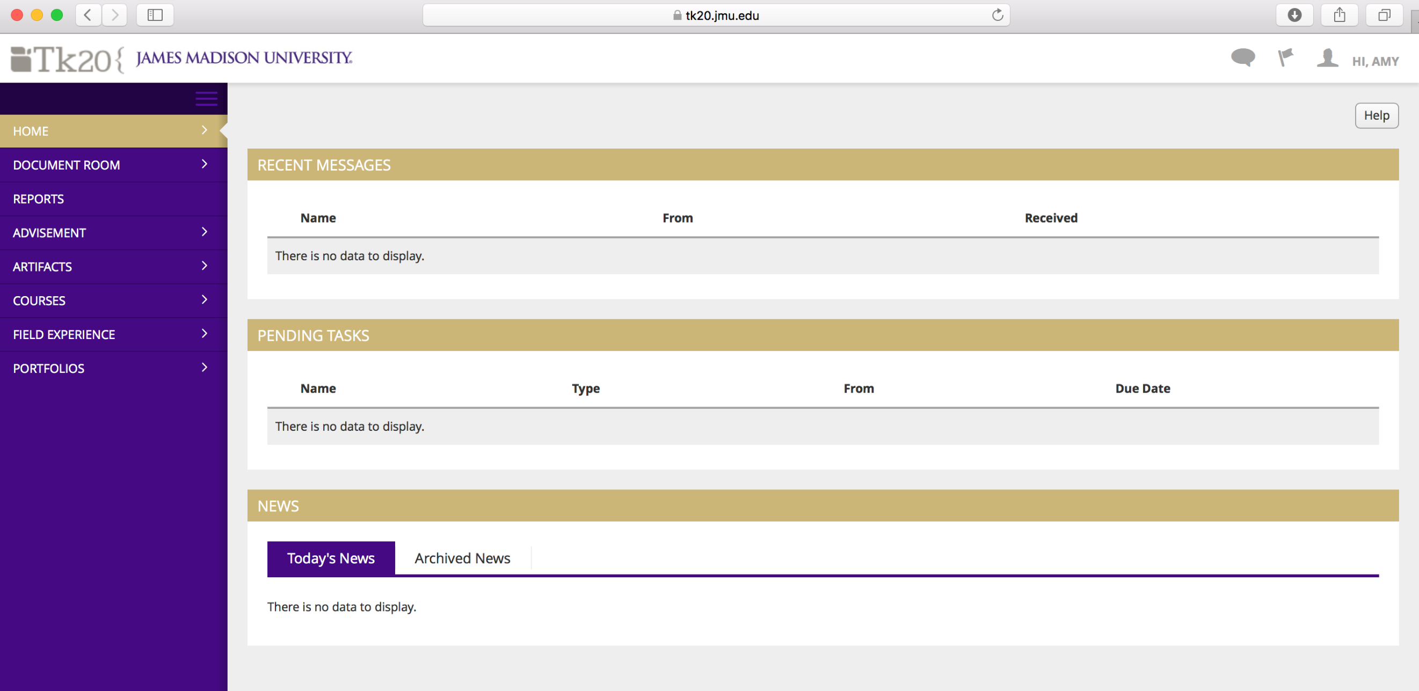

After you click on Courses, you’ll see a dropdown with additional choices. Click on Libraries. Go to Assessment Tools and then complete what you can on the Search screen then hit Search on lower right hand screen. (I searched for Student Teaching.) Anything that matches the search terms will show up on the bottom of the screen.
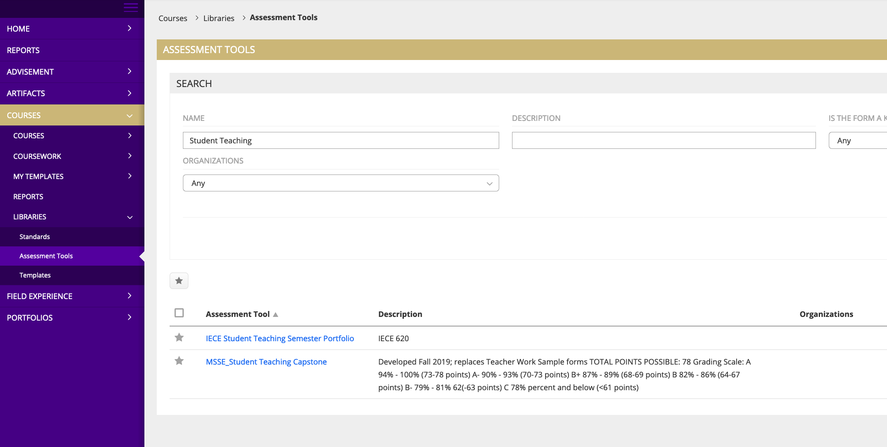

On the above screen, you’ll notice there is a star (★) next to the name of the assessment tool MSSE_Student Teaching Capstone. That just means I’ve used it to enter data before.

If you see a square instead ( ⃞ ) then check that box:

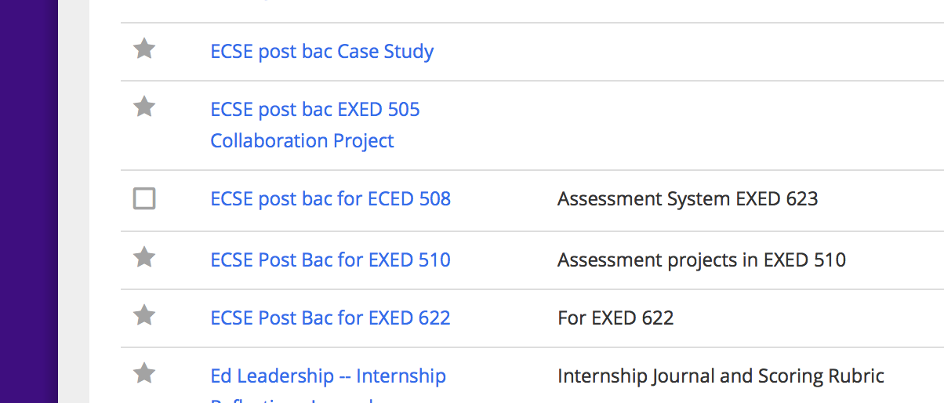

AND click on the star at the top of the list:
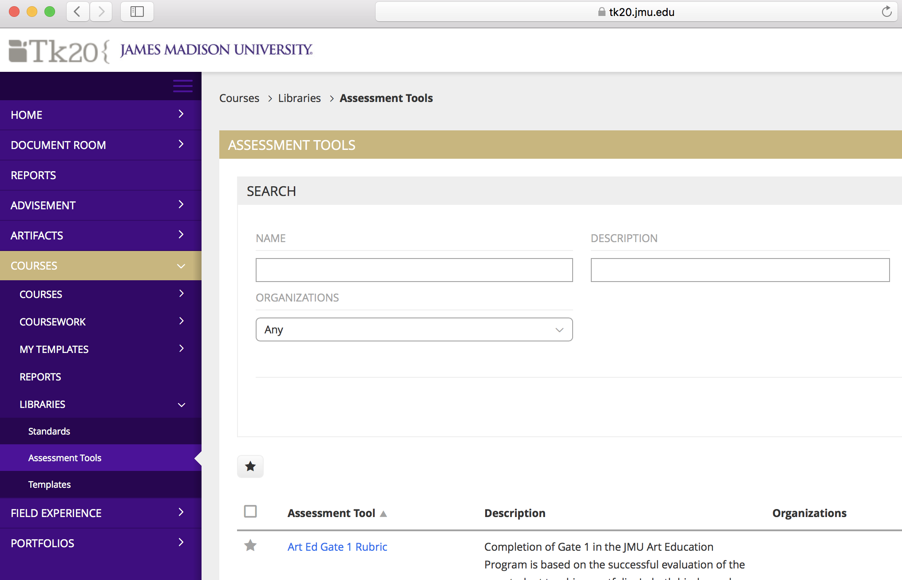
Now that you have found the assessment tool, you can enter the data for your course. Go back over to the left side, and click on Courses, then on Coursework, then on Observations, and finally on Assess. You’ll see a menu like what appears below, to help you choose your assessment tool and search for your course.

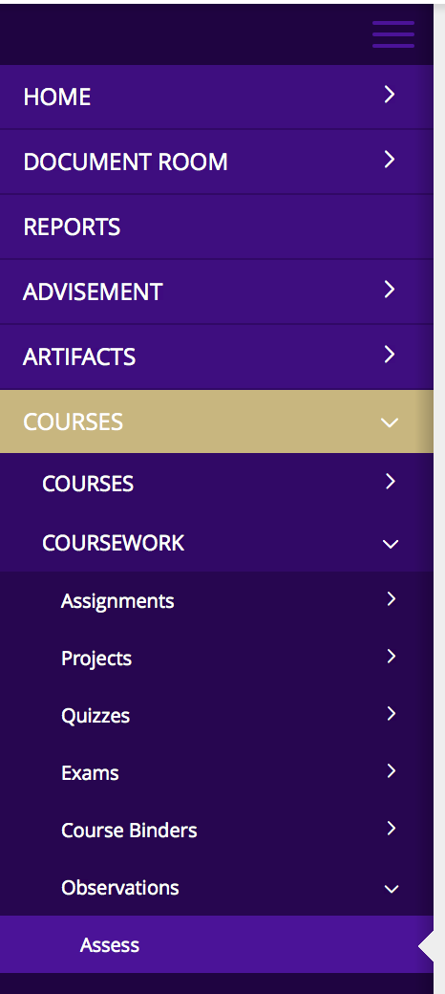

First, choose the assessment tool from the drop-down menu.

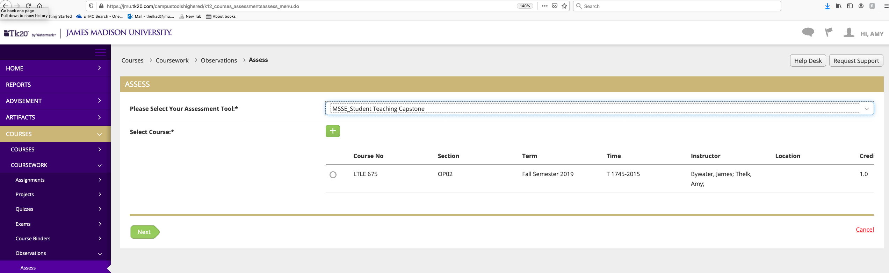

Then click on the. + sign next to Select Course to find your class. The screen below will appear.

If you fill in Subject and Term, you’ll find your course quickly and won’t have to fill out the entire form. Click on the box next to your course:

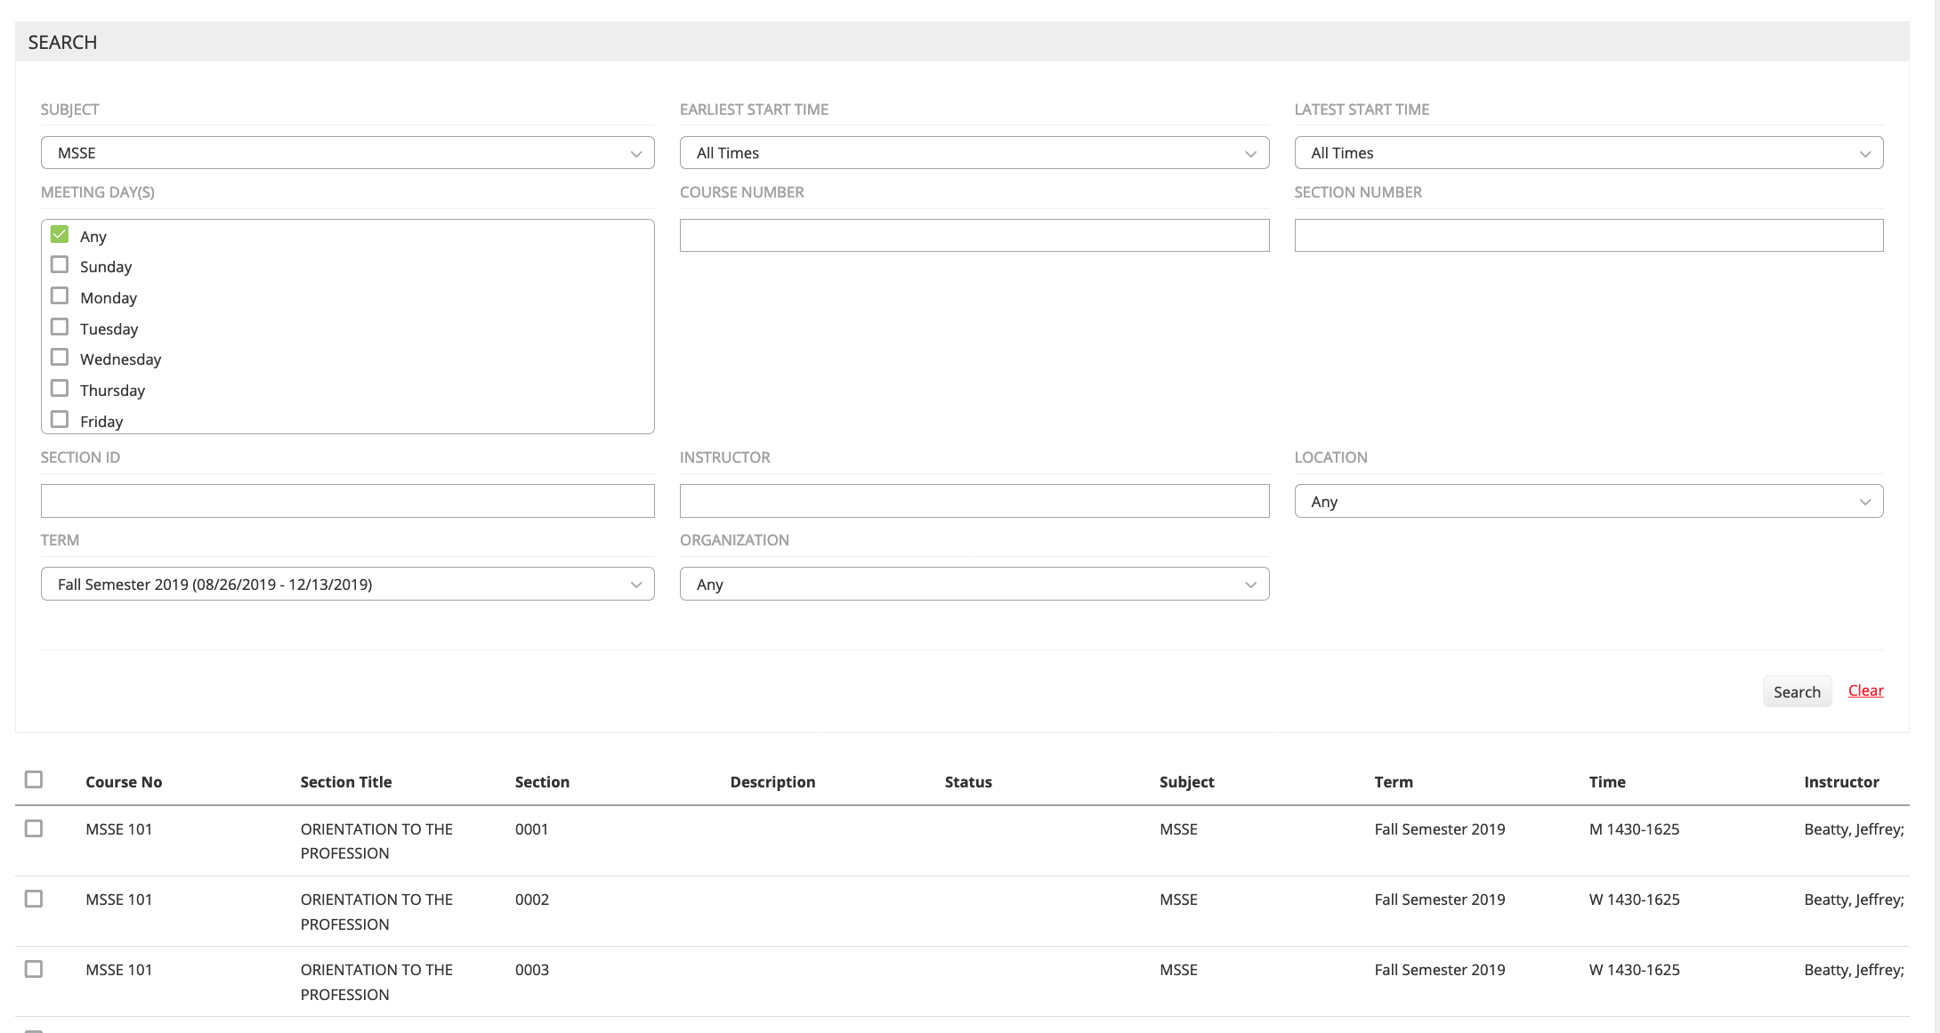

Hit the Add key in the lower right hand corner:
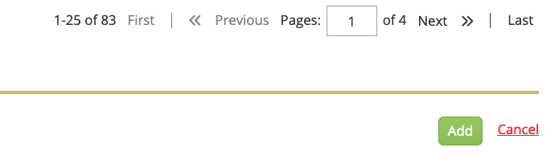

Hit the Next key in the lower left corner.
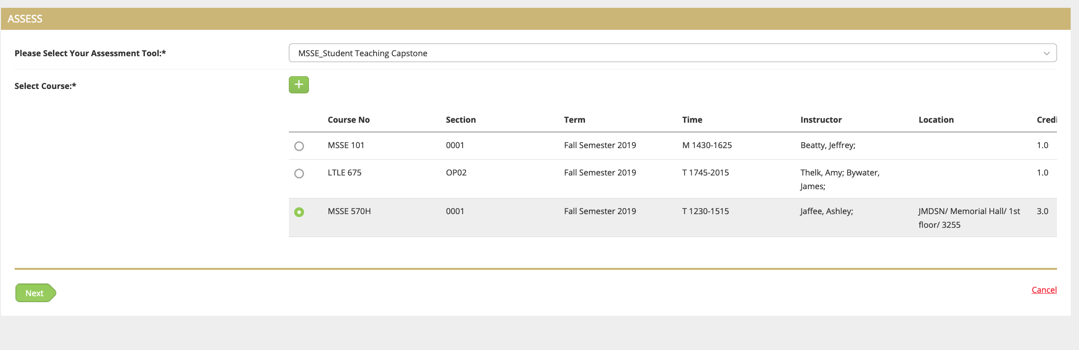

The students’ names will appear on the screen. To enter Breanna’s data, click on the + next to her name:

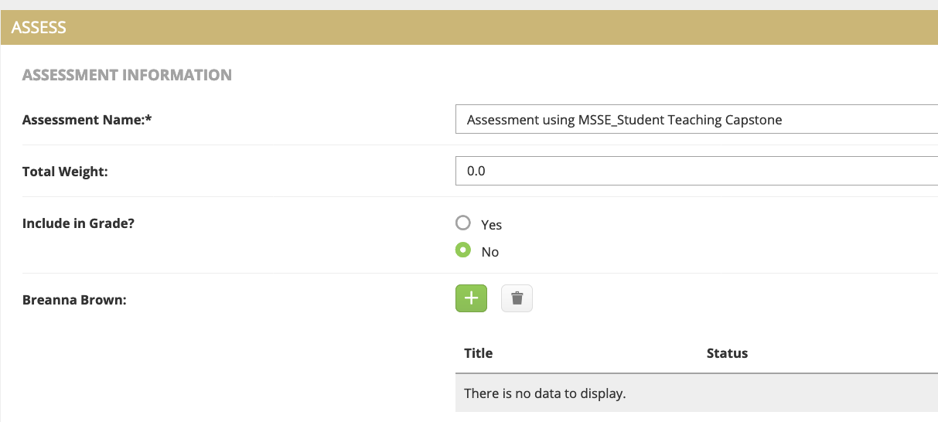

The rubric will appear. Click on the radio buttons that correspond to the scores she has obtained on the assessment.
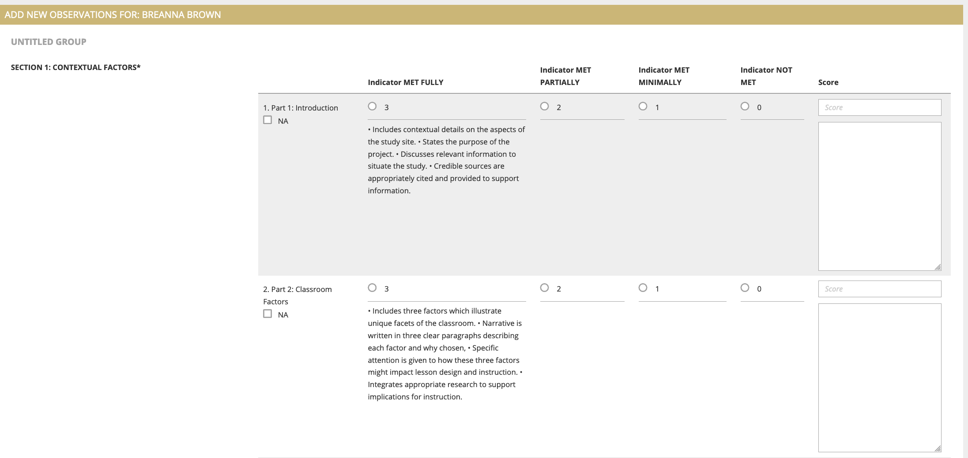

If for some reason you want to assign a score that is not in the assessment (like 2.5) -- click the radio button, then go over to the score box on the right side and adjust it

Use the text box to the right if there are comments you would like to include; use the NA box on the left if the candidate is not being graded on that particular aspect of the rubric.

When you are done, hit the submit key at the bottom.

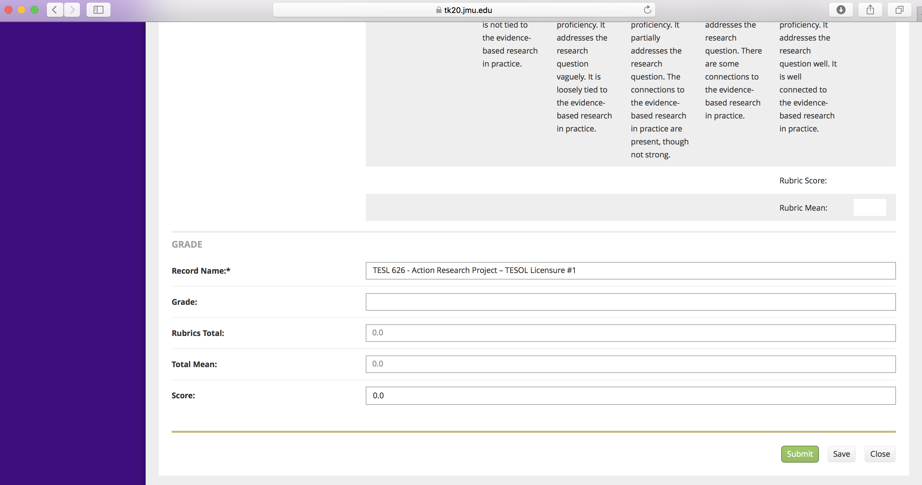

Repeat with other student names until you are done.

Hit Save when you are done entering data for your course.

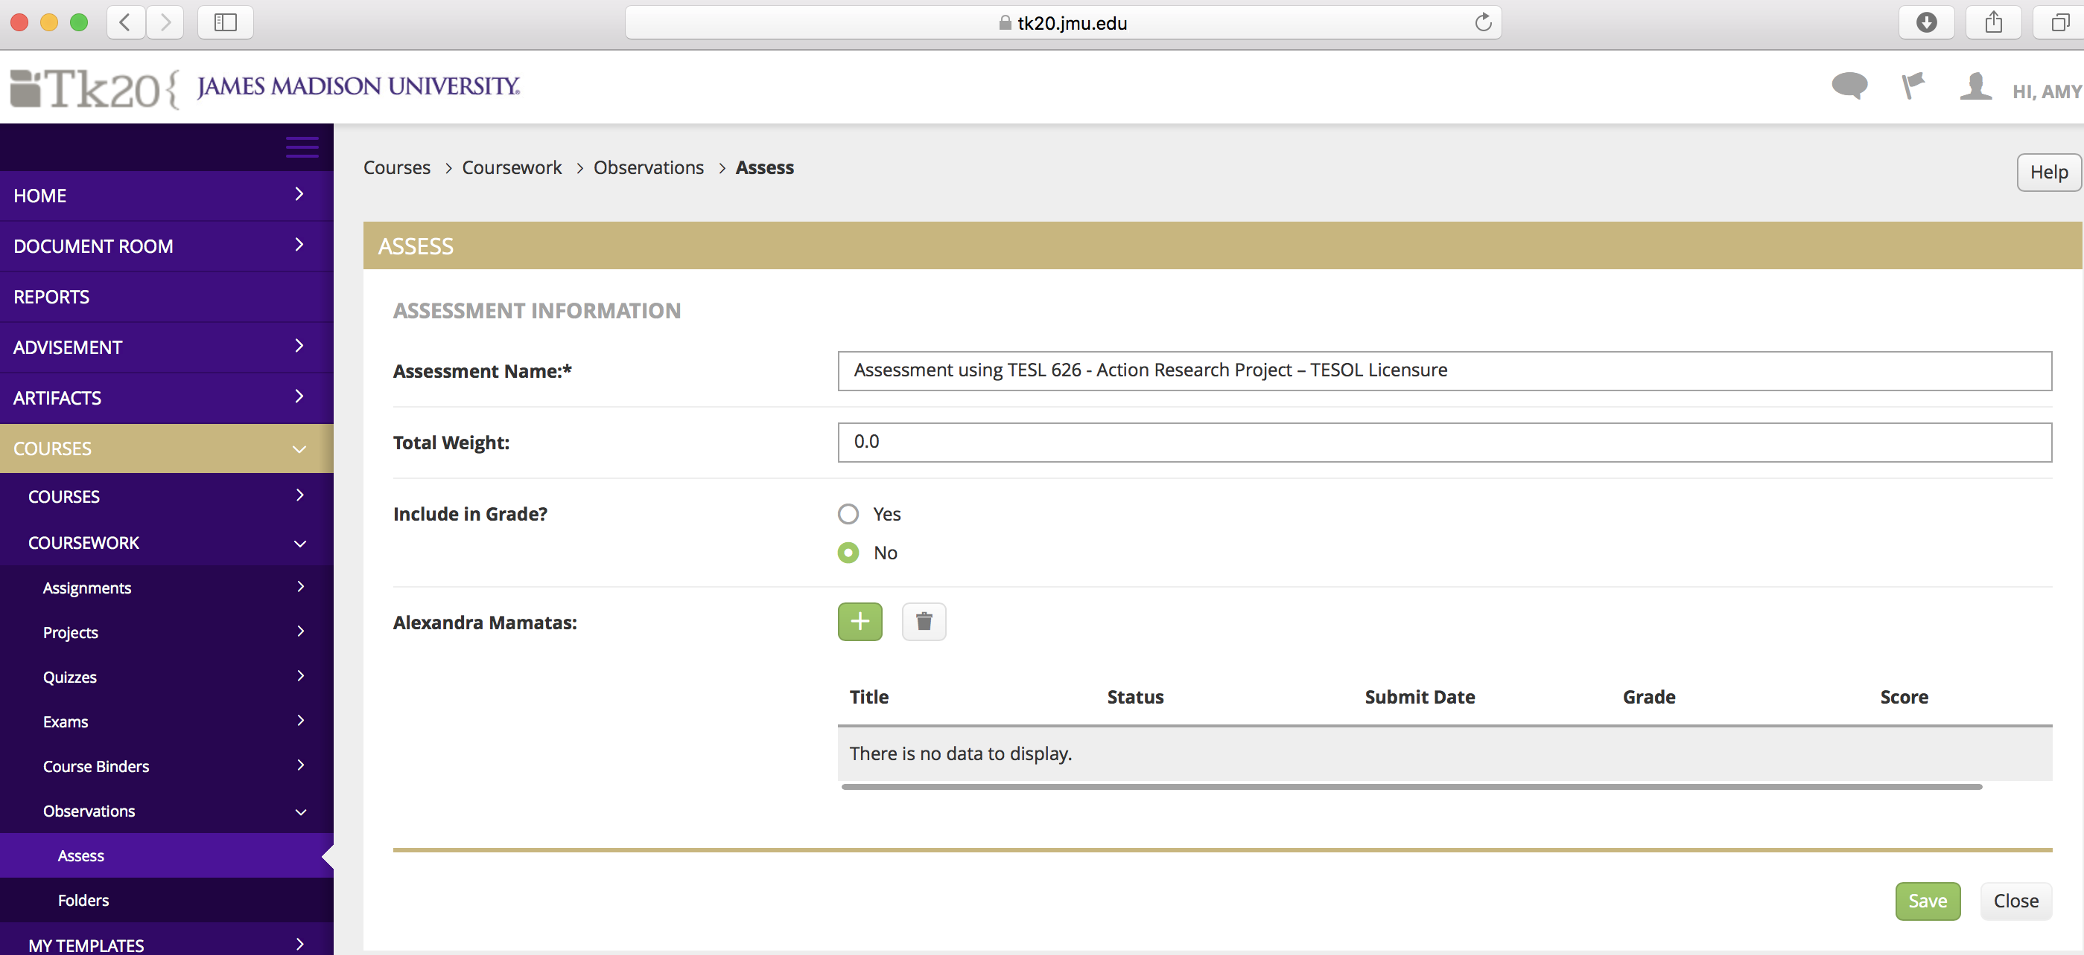

Want to check to see if your data all got entered correctly?

On the left side, click on Reports. The report we want is Courses 003 – you can browse for it or search for it in the box. Click on the title of the report when it appears on the screen. Any data you have entered will then appear. Each data entry episode will show up as a separate link. Choose the one you want and you will see your data.
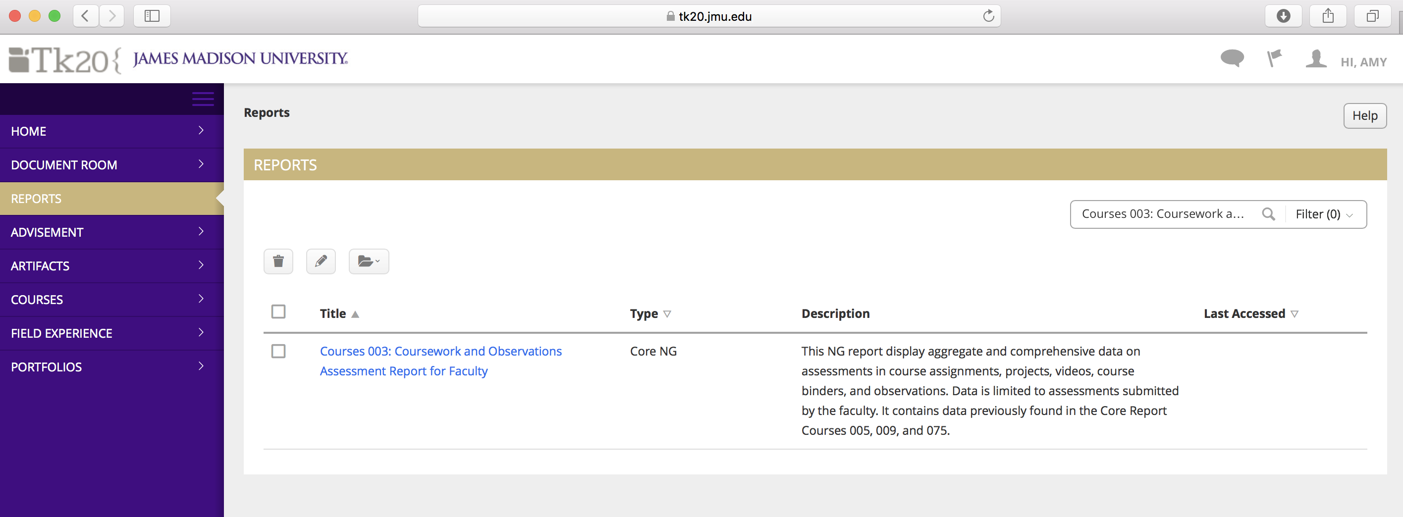

Good luck! Please let me know if you have any problems.
Amy Thelk / thelkad@jmu.edu (best way to reach me) / 8-3171

