Inclusion Activities - Elementary

Partner Mingle
When the music is playing, students travel around in general space (you can call out different locomotor skills). When the music stops, the teacher calls out a number (2-4) and a body part (e.g. foot to foot, elbow to elbow, etc.) and students quickly get into pairs or groups of 3 or 4. When everyone has a partner, ask a general question (e.g. “What is your favorite movie?”). See other examples below:
2 foot to foot: Favorite food
2 fist to fist: Pet you have or pet you wish you had
3 back to back: Siblings
3 elbow to elbow: Favorite sport or physical activity
2 finger to finger: Something you are good at
2 shoulder to shoulder: Something you are not good at yet
Between rounds, you can ask a reflection question (e.g. “What can we do if someone doesn’t have a partner?”) to help students identify and reflect upon behaviors that foster inclusion, belonging, acceptance, etc. Or, you can wait until the end of the game to ask reflection questions.
Some reflection questions:
If someone can’t find a partner, how can we help them?
Raise your hand if you learned something new about someone. We identified similarities and differences.
How does learning about each other help us create an environment of belonging? (I realize that other people are like me; I realize that differences aren’t scary, etc.)
How did you show belonging, acceptance, and value when we played the mingle game?
How might you show belonging, acceptance, and value when you are outside at recess, or in the lunchroom?

River Crossing
Divide students into groups of 4ish. Each group has a pile of equipment and must choose 4 pieces of equipment (or however many pieces of equipment as the number or people they have in their group). Each group works cooperatively to get every member of their group from point A to point B (distance can be 10-15 yards). You can tell a story about getting stranded on an island, and these are the only objects they have to get them back across to the mainland. If any part of their body touches the floor, they get eaten by a sea/river creature and the whole group has to start from the beginning. They also have to have a part of their body touching one of the objects at all times. If one of the objects is left “floating” in the water, the sea/river creature will eat it (i.e. the teacher will take it away) and they have to make it the rest of the way without that object. When a group gets across successfully, they raise their hands and the teacher gives each group member (or just one or two group members) a disability.
1. Blindfold
2. Lost use of one hand (holds scarf in other hand)
3. Loss of voice
4. One student can only sit on scooter and cannot propel herself.
Debrief/Reflection Questions:
How does your group need to change its strategy to accomplish the goal? What do you need to do to ensure everyone in your group was included?
Were you successful/did you achieve your goal? If so, what helped your team achieve your goal?
What challenges did your team face?
Did anyone feel like they had a good idea that wasn’t heard? What might you do differently next time? (Remember to ask if they took enough time to discuss their ideas before beginning)
Was there anything your group could have done to make the activity more inclusive?
How did you show empathy or caring toward your group members?

Scarf Volley
This activity can be done as an instant activity or lead-up activity to the Quarterback Challenge (throwing and catching in a dynamic setting). As students enter the gym, they find a partner, a scarf, and a ball and see how many consecutive toss/catches they can make. They are working together (one partner holds one side of the scarf and the other partner holds the other side) to toss the ball and catch it with the scarf. You could also use a handkerchief. Have students freeze, one partner sit down, the other partner goes to find a new partner and play another round. This gives students an opportunity to work with different people in the class for short periods of time.
Reflection Questions
How did you and your partner work together to be successful?
What adjustments did you make, if any? Did you talk about/agree on those adjustments?
Think about what you can take from this activity and apply to our quarterback challenge today (In the Quarterback Challenge, students will need to communicate with their partner to make choices about the type of ball they want to use, distance to run/throw, running pattern, etc.). The goal is to work together to be successful as a pair, which will require them to communicate and make adjustments.

Quarterback Challenge
This activity is for 4th and 5th graders, towards the end of a throwing/catching unit. Students work in groups of 3 (could do groups of 4 if necessary). 1 hiker, 1 thrower, 1 catcher. Each group has 3 cones, a variety of types of balls, a football field recording paper, and a pencil or post-it marker to record their advancing yards. The cones are set up with a starting cone, another cone approximately 5 yards away, and a third cone approximately 10 yards away. The center (hiker) hikes the ball to the thrower, the receiver runs out for the pass. The receiver has a choice to run to the 5 or 10-yard cone. The goal is to make complete passes to score a touchdown. With each complete pass, the group records their additional progress down the field on the recording paper.
Choices:
Type of ball (different sizes, textures, etc…all options should be appropriate for this age/developmental level and can include a small football)
Distance for the pass
The goal - group decides together whether the goal is to score a touchdown or they can set a goal # of complete passes
Once your group has scored a touchdown, the group decides together whether they want to try for another, or compete with another group to see who can score a touchdown first.

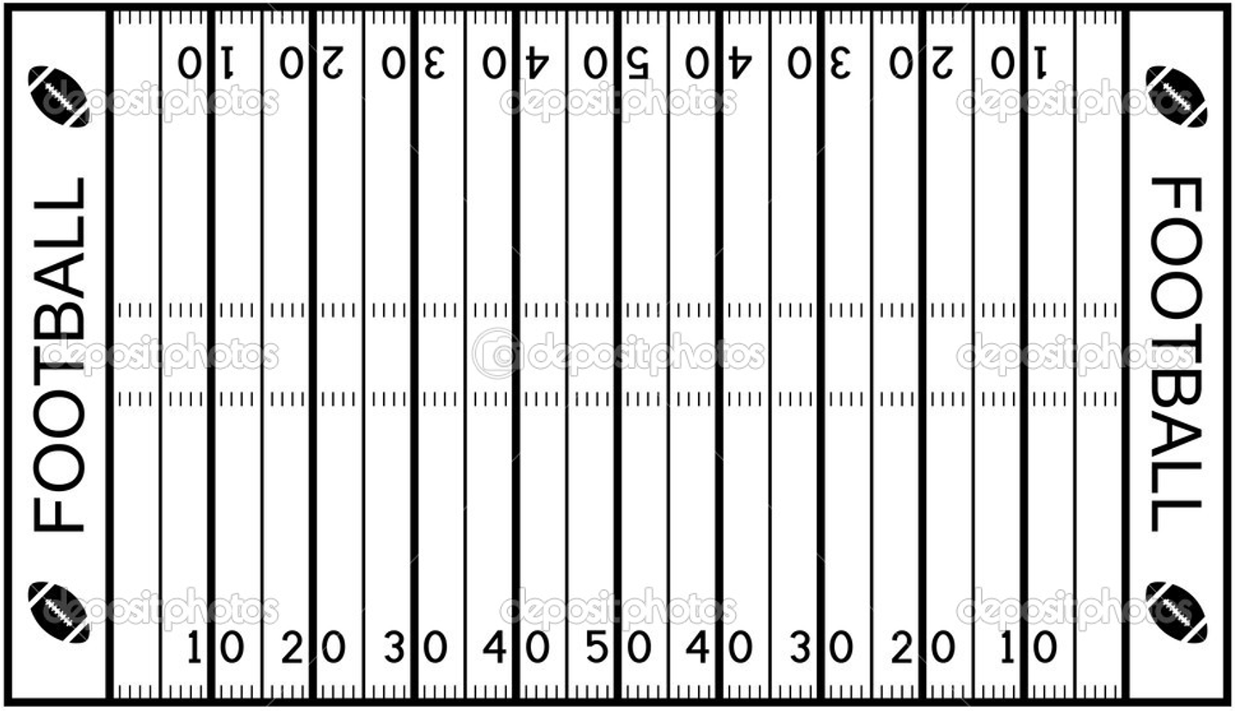
Reflection Questions
What aspects of inclusion did you experience or feel were missing in the game? (E.g. The group allowed each member to choose which ball to use when it was their turn so that all members could experience success).
Did your group make any changes to make the game more inclusive? (E.g. They might have adjusted the distance or the receiver might have asked the QG to throw the ball softer)
How did you show empathy or caring toward your teammates? (E.g. “I provided helpful feedback to my teammate,” or “I encouraged my teammate when he dropped the pass,” or “I switched the ball we were using because it made my teammate more comfortable,” or “My teammate wanted to bigger challenge when he was the receiver so we had the hiker play passive defense.”)

Change it up
Adapted from: https://www.coe.int/t/dg4/education/pestalozzi/Source/Documentation/TU/TU_SPORT_BARAN_EN.pdf
The premise here is that everyone has the right to experience success and joy through physical activity. Everyone is different, and has different strengths to bring to the activity. There are many games and activities that allow only some students to experience success and joy. Challenge students to take a traditional game and “change it” (see the acronym below) to make it promote feelings of inclusion, which support feelings of acceptance, belonging, and all students being valued (they should already be familiar with this vocabulary). You might suggest a game that they play at recess (e.g. kickball or 4-square) so that they can think about how these skills transfer beyond physical education. You could present scenarios to consider (see below), or you could give each group a different game/activity to work with.
Provide a variety of equipment for each group to use in their game. Groups should be no larger than 5.
Introduce the acronym:
Coaching style – e.g. demonstrations, use of questions, role modeling, verbal instructions
How to score or win
Area – e.g. size, shape, or surface of playing area
Number of participants
Game rules – e.g. number of bounces or passes
Equipment – e.g. softer or larger balls, lighter, more/less bounce
Inclusion – e.g. everyone has to touch the ball before team can score
Time – e.g. “How many…in 30 seconds?”

Give students sufficient time to discuss the traditional version of the game and the factors that contribute to or detract from inclusivity. Ask them to come up with as many ways as they can that the game could be modified, using the “CHANGE IT” acronym. They should write their ideas on poster paper.
If you are doing this outside and you have enough space, each group can have a designated space to try out the various modifications and discuss whether and how it promotes inclusivity.

Potential Scenarios to Present:
A new classmate, Ayaz, just moved from a different country. They do not speak English and they have never played kickball before, so they are afraid to join the game. They don’t understand the rules and they are afraid of messing up in front of their new classmates.
Jaylen is a classmate who has always wanted to play kickball but has always been hesitant to join because they do not have good kicking skills. They are afraid that they might kick and miss or get out right away. They are also unsure of when to run and when to stay on base, and they are worried about throwing the ball to the wrong person if the ball comes to them in the field.
Cortez is a classmate who uses a wheelchair. They have always wanted to join the kickball games at recess but were afraid that no one would want them on their team. They also know that they would need some adaptations to be able to play. The other kids in class always just assumed that Cortez wasn’t interested in playing kickball.

