AB Crunch Progression
Beginner Level
Name | Description
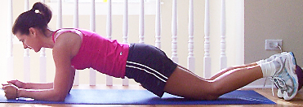  Plank | Level 1 - Elbow/Knee  Level 2 – Elbow/Toe  Level 3 – Hand/Knee  Level 4 – Hand/Toe  Level 5 – Hand on floor/Shins on stability ball  Level 6 – Elbow Circles on stability Ball/Toes on floor
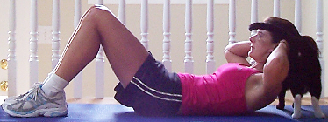  Crunches | Lie on your back with your hands crossed across your chest or with your fingers on the sides of your head. Place your feet on the floor with legs bent. To begin the exercise, lift your torso, lifting shoulder blades off the floor and crunching your rib cage towards your lower belly. Hold for two counts, then lower slowly to the starting position. Repeat.
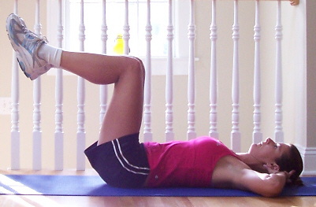  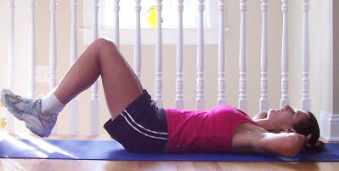  Reverse Crunches | Lie on your back with knees bent, feet a few inches off the floor. Slowly contract the abdominals, focusing on rotating the pelvis up and bringing your knees towards your rib cage. Concentrate on letting your abs do the work. Hold at the top then slowly lower your knees to the starting position. Repeat.
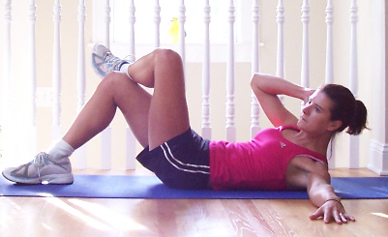  Oblique Crossover Crunches | Lie on your back with knees bent, hands behind your head. Keeping lower back pressed into the floor, lift your shoulder blades off the floor and then curl your upper body diagonally across your body towards your right knee. Contract your abs and obliques as hard as you can at the top of the movement. Lower back down and repeat on the same side before switching sides.
Dead Bug  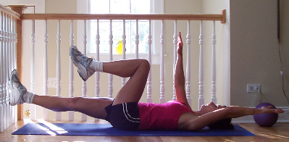 | Begin by lying on back, knees up and bent at 90 degrees. Take the arms straight up overhead and hold this position for a moment, making sure abs are in tight and your back isn't arching off the floor (if it is, lower the feet to the ground for this exercise). Slowly lower the right arm and left leg towards the floor while keeping the lower back on the floor. Bring them back up and lower the left arm and right leg to the floor. Continue lowering opposite arm and leg for a total of 10 reps.
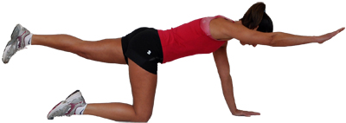  Superhumans | Begin on hands and knees, hand directly under shoulders, knees under hips and back straight, abs tight. Slowly raise right arm and left leg up until level with the body, holding your balance and keeping torso tight. Lower back down and repeat with the left arm and right leg. Take your time--this exercise will challenge your balance!
Intermediate Level
Name | Description
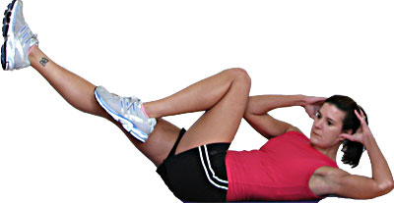  Bicycle | Lie on the floor and lace your fingers behind your head, knees into the chest. Lift the shoulder blades off the floor and straighten the left leg out while simultaneously turning the upper body, taking the left elbow towards the right knee. Switch sides, bringing the right elbow towards the left knee. Continue alternating sides in a 'pedaling' motion for 16 reps (1 rep is to the right and left).
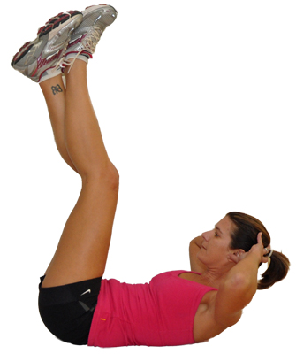  Vertical Crunch | Lie on the floor and extend the legs straight up with knees crossed. Place your hands behind the head for support and contract the abs to lift the shoulder blades off the floor, as though reaching your chest towards your feet. Lower and repeat for 16 reps.
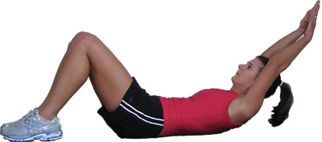  Long Arm Crunch | Lie on a mat and extend the arms straight out behind the head with hands clasped, keeping the arms next to the ears. Contract the abs and lift the shoulder blades off the floor, keeping the arms straight. Lower and repeat for 16 reps.
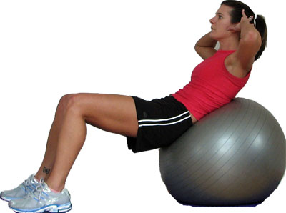  Ball Crunch | Lie with the ball resting under the mid/lower back and place hands behind the head or across the chest. Contract your abs to lift your the torso off the ball, pulling the bottom of your ribcage down toward your hips. Lower and repeat for 16 reps.
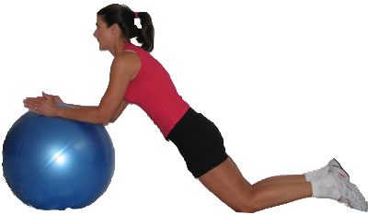  Ab Roll | Kneel in front of the ball and place your hands on the ball parallel to one another. Roll the ball out keeping the hips straight and back straight. Roll out until you feel the abs engage (don't arch or strain the back) and push into the ball to roll back in. Repeat for 16 reps.

