Code of Virginia §23-2.6.
Transparency in Higher Education Information
Each four-year public institution of higher education shall maintain and update annually no later than September 30 a tab or link on the home page of its website that shall include the following information:
The institution’s six-year undergraduate rate for each of the past ten years;
http://www.jmu.edu/instresrch/statsum/2014_15/T2-25_2014.pdf
The institution’s freshman-to-sophomore retention rate for full-time undergraduate students for each of the past ten years;
http://www.jmu.edu/instresrch/statsum/2014_15/T2-26_2014.pdf
The institution’s average annual percentage increase in base undergraduate tuition for each of the past 10 years;
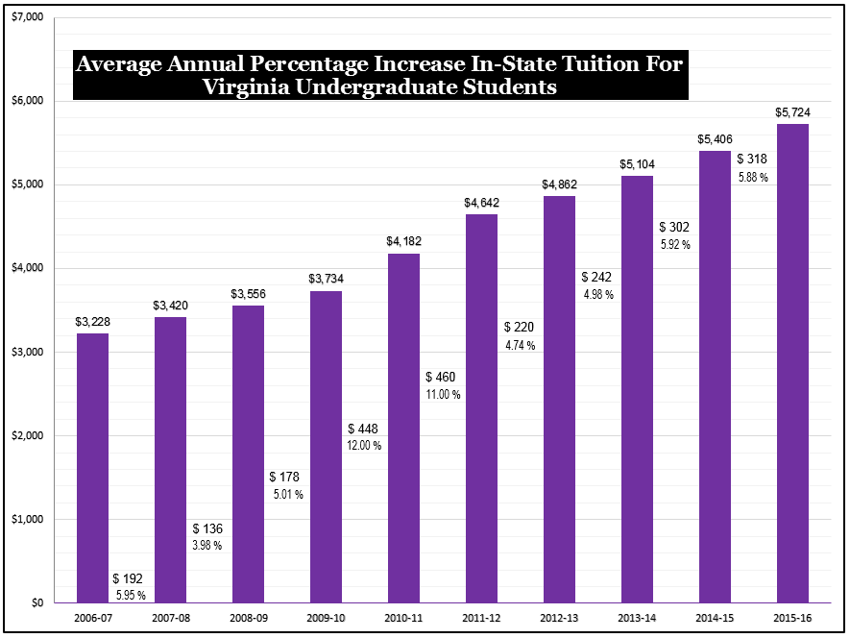

The institution’s average annual percentage increase in mandatory undergraduate comprehensive student fee for each of the past 10 years;
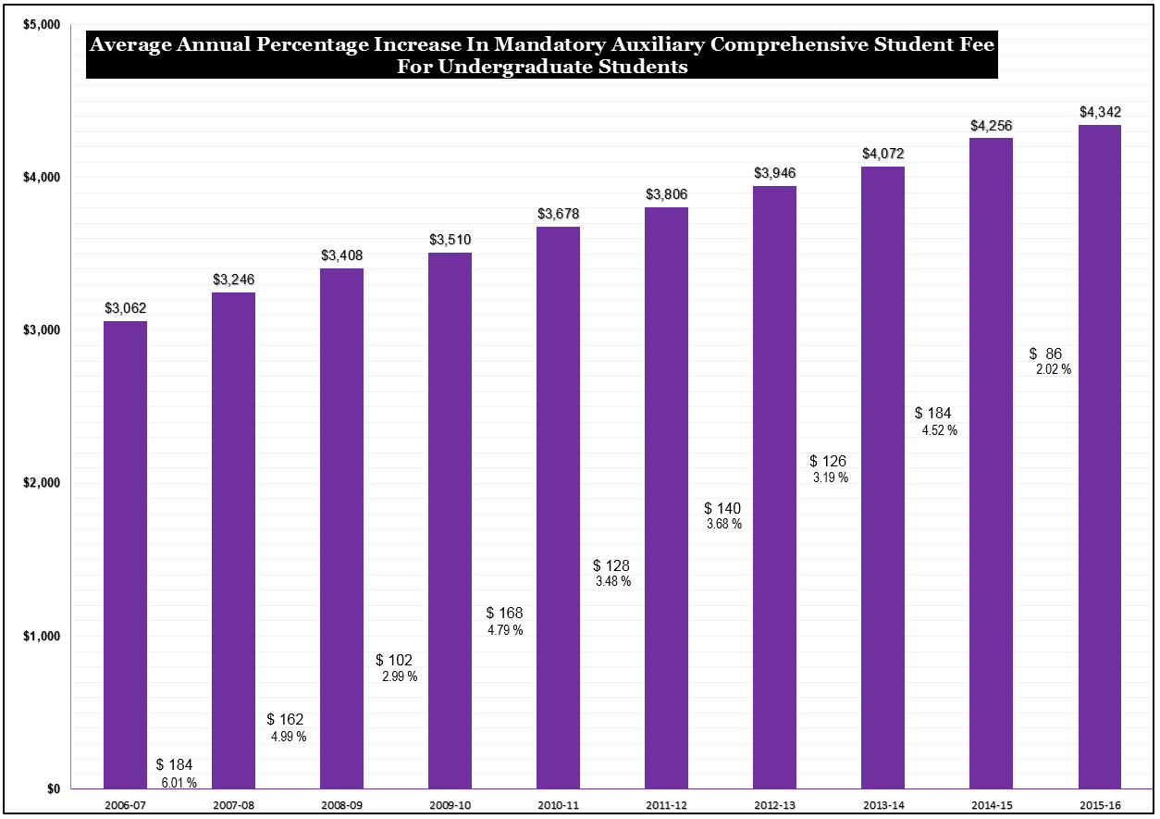

A link to the annual report of the use of student fees as required by §23-2.3;
http://www.jmu.edu/universityunions/budget/approvedbudgets.shtml
A link to the postsecondary education and employment data referenced in §23-2.4; and
http://research.schev.edu/iprofile.asp?UID=232423
A summary of the institution’s budget, consistent with the institution’s annual budgeting process, that includes (i) the major budget units (MBUs) in the institution and standard expenditure categories within each MBU for the current fiscal year and the previous fiscal years or (ii) a link to the annual reports required by §23-1.01.
http://www.jmu.edu/financeoffice/accounting-reporting/financial-reporting/annual-financial-statements.shtm

