Finding and Setting up Access to Google Calendar

- Go to any Google page (google.com, Google Docs, Google Drive, whatever) and look for a group of nine dots in the upper right hand corner. 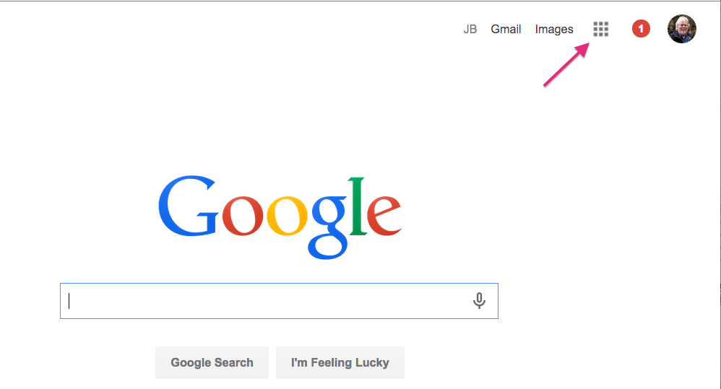
- Click on there and you should see a list of Google apps. Calendar should be near the bottom.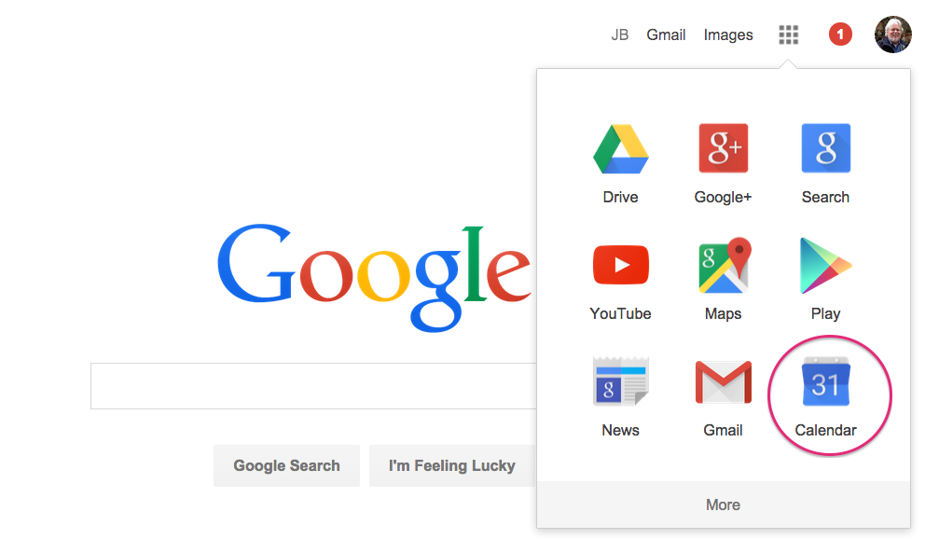

- Open Calendar and then click on your image or icon in the upper right hand corner to open up a list of your Google accounts (mine is a picture you can see in the photos above, since it automatically recognizes me as a Google subscriber).

- Click on 'Add Account' at the bottom of that screen. If you have added the biology faculty account, you should see it as a choice there. If it's not there yet, use the username and password I provided (or will provide, at your request) to add that account.

- From there you should see the faculty/staff calendar and be able to make changes to it.

