Photographs of Suspects

David Charles Russell
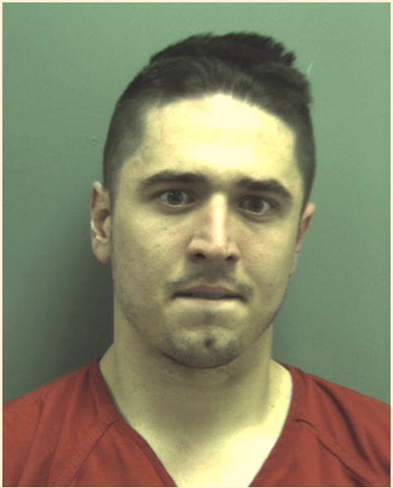

Dean W. Ballard
